Computer Networks (21CSC302J) PPP (Point-to-Point Protocol) in Cisco Packet Tracer using two routers connected through a serial link.
1. Aim of the Practical
Experiment: To configure and verify Point-to-Point Protocol (PPP) between two routers using Cisco Packet Tracer.
Objectives:
- Understand the working of PPP.
- Establish a point-to-point WAN connection between two routers.
- Configure PPP encapsulation on serial interfaces.
- Verify connectivity using ping and router commands.
- Understand the role of LCP and NCP in PPP.
2. What is PPP?
PPP (Point-to-Point Protocol) is a Data Link Layer protocol used to establish a direct connection between two network devices over a point-to-point link.
For example, two routers in different locations can communicate over a WAN connection using PPP.
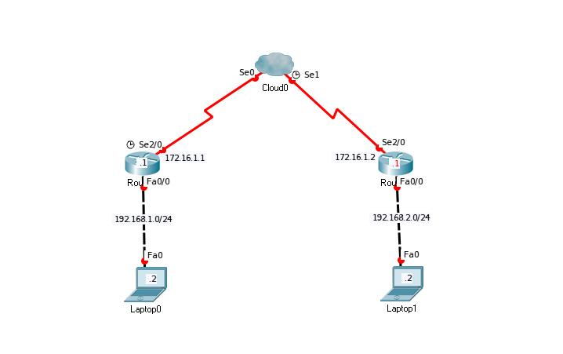
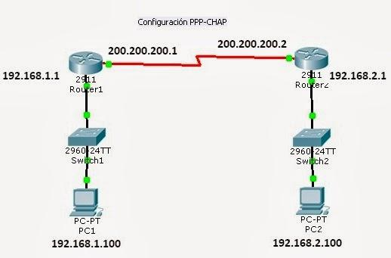
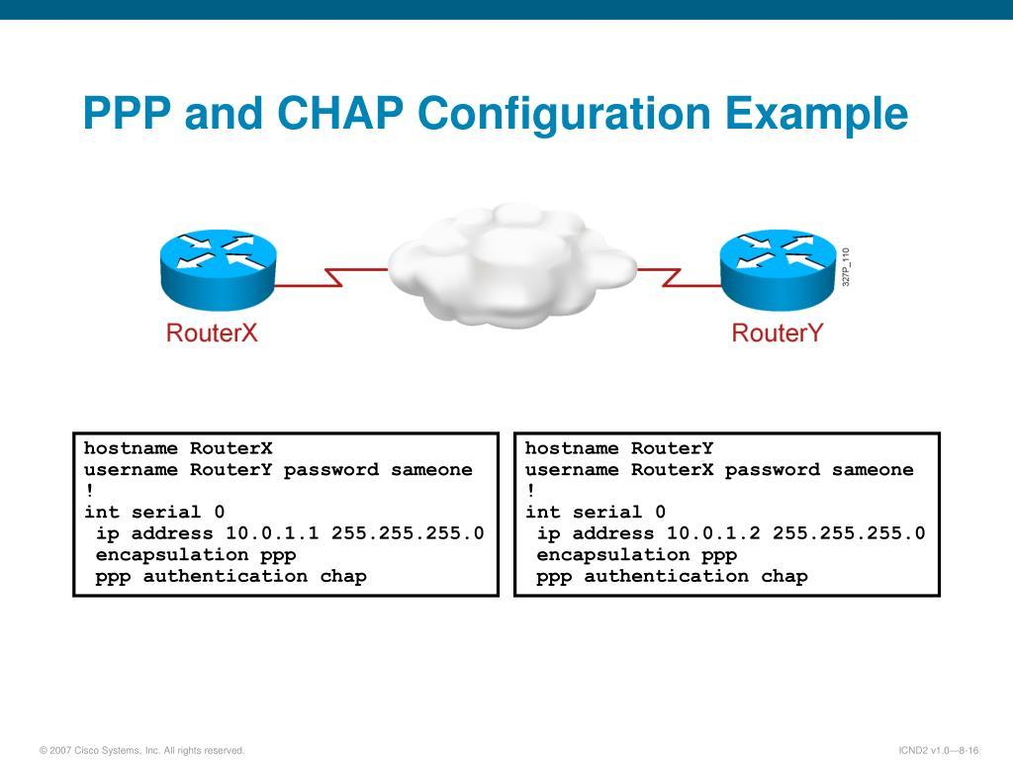
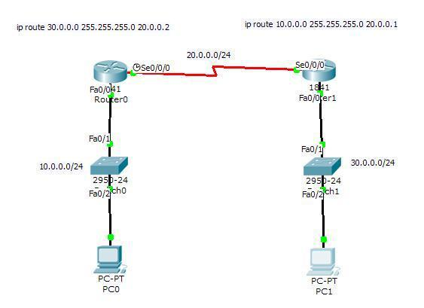

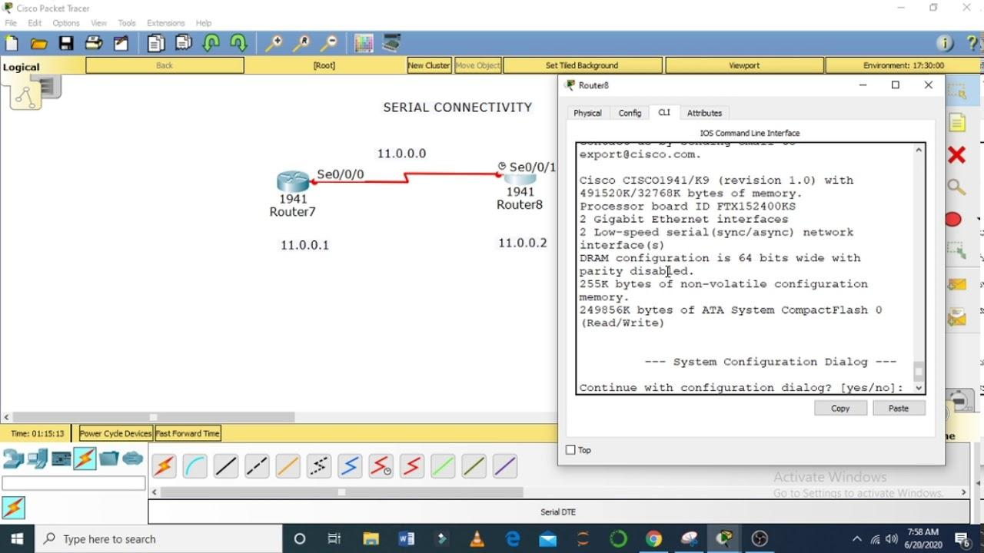
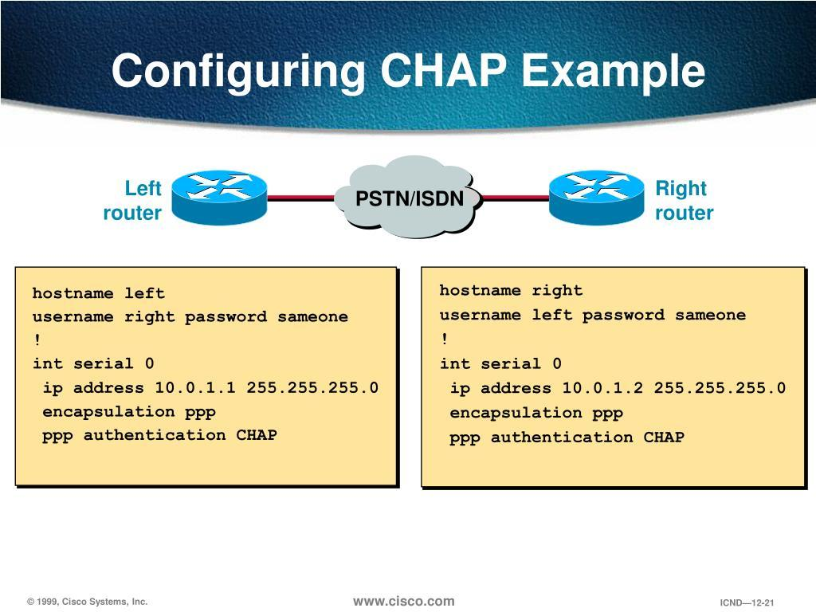
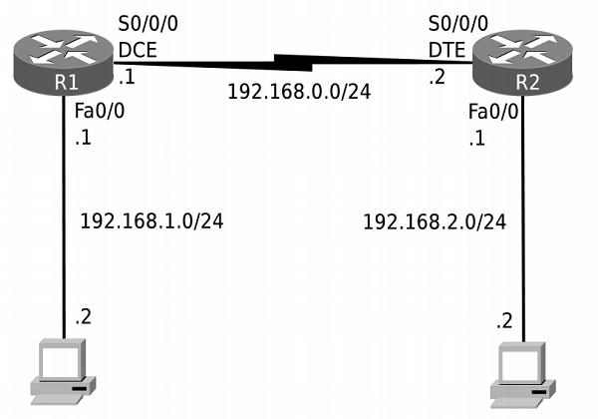
Key features of PPP
Feature | Explanation
OSI Layer | Data Link Layer (Layer 2)
Connection | Point-to-point
Encapsulation | Encapsulates network-layer packets
LCP | Link Control Protocol; establishes and configures the link
NCP | Network Control Protocol; configures network-layer protocols
Authentication | Supports PAP and CHAP
Error detection | Uses FCS to detect transmission errors
Multiple network protocols | Can carry IP and other network-layer protocols
PPP provides a standard method for transporting network-layer packets across a direct link between two devices.

3. Create the Topology in Cisco Packet Tracer
We will use two routers and two PCs.
Required devices
- 2 routers
- 2 PCs
- 2 copper straight-through cables
- 1 serial DCE/DTE connection between the routers
Use router models that support serial interfaces, such as the Cisco 1941 or 2811, if available in your Packet Tracer installation. Depending on the model, you may need to install a serial interface module before powering on the router.
Topology
PC0 PC1
| |
| |
R1 ======= PPP ===== R2
Serial Link
The serial link between R1 and R2 will use PPP encapsulation.
IP addressing table
Device | Interface | IP Address | Subnet Mask
PC0 | FastEthernet0 | 192.168.1.2 | 255.255.255.0
R1 | G0/0 | 192.168.1.1 | 255.255.255.0
R1 | S0/0/0 | 10.0.0.1 | 255.255.255.252
R2 | S0/0/0 | 10.0.0.2 | 255.255.255.252
R2 | G0/0 | 192.168.2.1 | 255.255.255.0
PC1 | FastEthernet0 | 192.168.2.2 | 255.255.255.0
Default gateways:
- PC0: 192.168.1.1
- PC1: 192.168.2.1
The PPP connection will use the 10.0.0.0/30 network.

4. Configure Router R1
Open R1, select the CLI, and enter the following commands.
enable
configure terminal
hostname R1
interface gigabitEthernet 0/0
ip address 192.168.1.1 255.255.255.0
no shutdown
exit
interface serial 0/0/0
ip address 10.0.0.1 255.255.255.252
encapsulation ppp
no shutdown
exit

ip route 192.168.2.0 255.255.255.0 10.0.0.2

end
Save the configuration:
copy running-config startup-config
Important point
The most important command for your practical is:
encapsulation ppp
It changes the serial interface's encapsulation from the default HDLC to PPP.
Note: If R1 is the DCE end of the serial cable, configure a clock rate:
configure terminal
interface serial 0/0/0
clock rate 64000
end
You can identify the DCE end using:
show controllers serial 0/0/0
Only the DCE end needs to provide the clock signal.

5. Configure Router R2
Open R2's CLI.
enable
configure terminal
hostname R2
interface gigabitEthernet 0/0
ip address 192.168.2.1 255.255.255.0
no shutdown
exit
interface serial 0/0/0
ip address 10.0.0.2 255.255.255.252
encapsulation ppp
no shutdown
exit

ip route 192.168.1.0 255.255.255.0 10.0.0.1

end
Save the configuration:
copy running-config startup-config
Important: Both ends of the serial connection must use PPP encapsulation. If one router uses PPP and the other uses HDLC, the link will not operate correctly.

6. Configure the PCs
Configure the IP settings through Desktop → IP Configuration on each PC.
PC0
Setting | Value
IP Address | 192.168.1.2
Subnet Mask | 255.255.255.0
Default Gateway | 192.168.1.1
PC1
Setting | Value
IP Address | 192.168.2.2
Subnet Mask | 255.255.255.0
Default Gateway | 192.168.2.1

7. Verify PPP Configuration
This is the most important part of your live practical.
A. Check interface status
On R1, execute:
show ip interface brief
You should see the serial interface with an IP address and, once the connection is established, its status and protocol should both be up.
B. Verify PPP encapsulation
Execute:
show interfaces serial 0/0/0
Look for output similar to:
Encapsulation PPP
The exact output depends on the router model and Packet Tracer version.
This confirms that PPP is configured on the serial interface.
C. Test router-to-router connectivity
From R1:
ping 10.0.0.2
A successful ping confirms IP connectivity across the serial link.
D. Test PC-to-PC connectivity
On PC0, open Desktop → Command Prompt and execute:
ping 192.168.2.2
If the IP addresses, interfaces, PPP link, and static routes are configured correctly, PC0 should communicate with PC1.
The first ping may time out while ARP resolves the destination MAC address. If that happens, try the ping again.

8. How PPP Works
This is where you can connect the practical practical to the theory.
PPP operates through several stages.
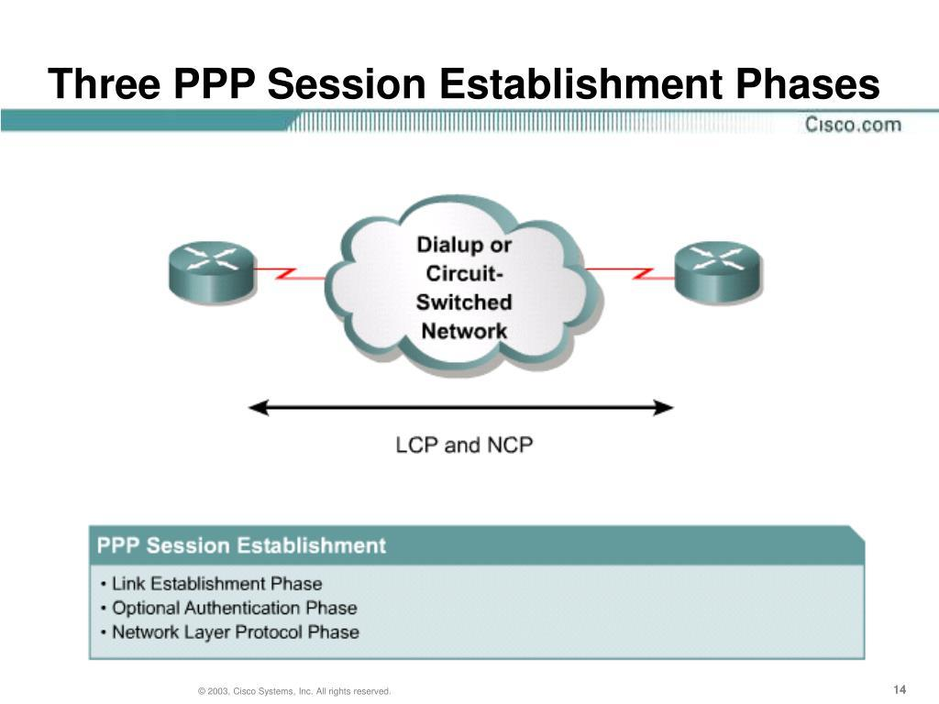
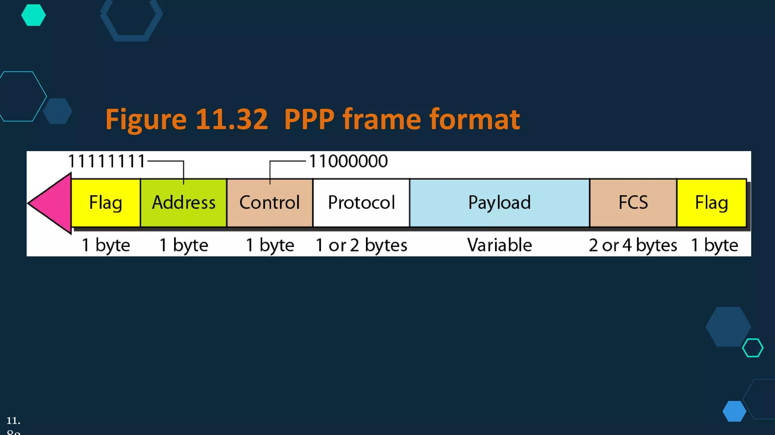
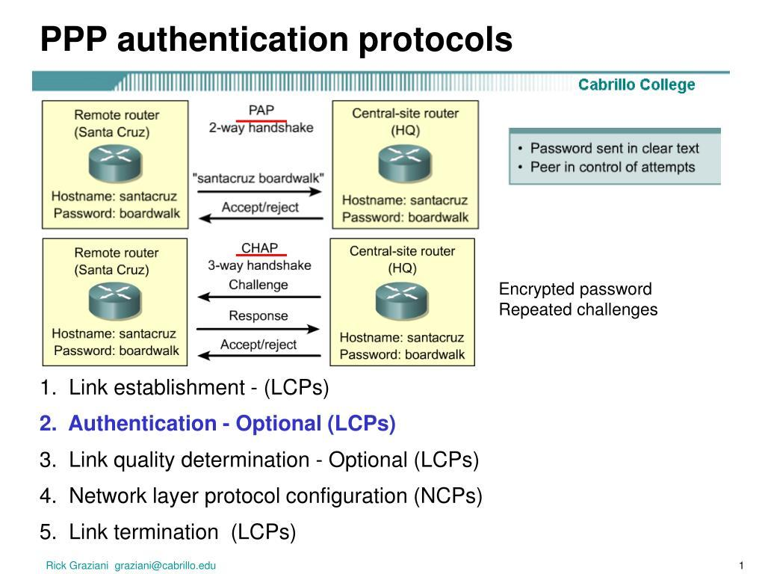
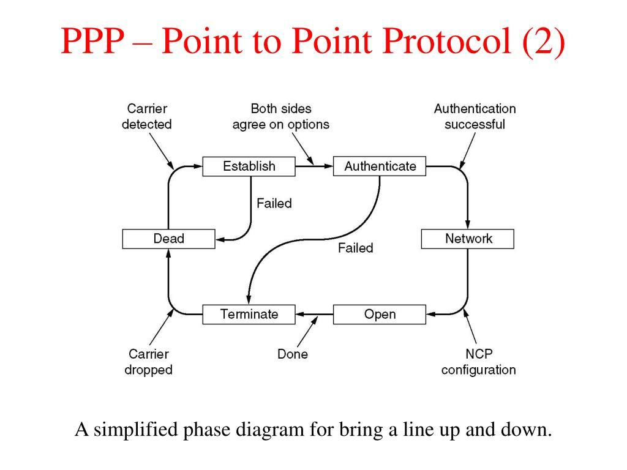
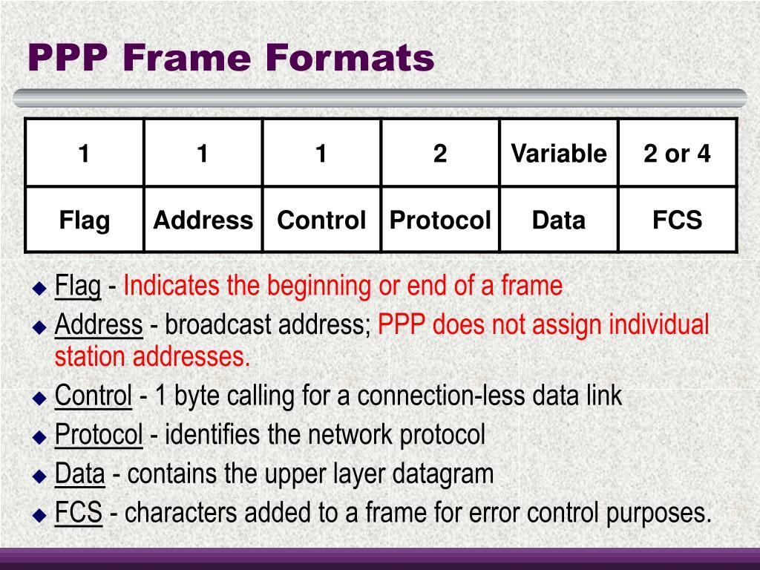
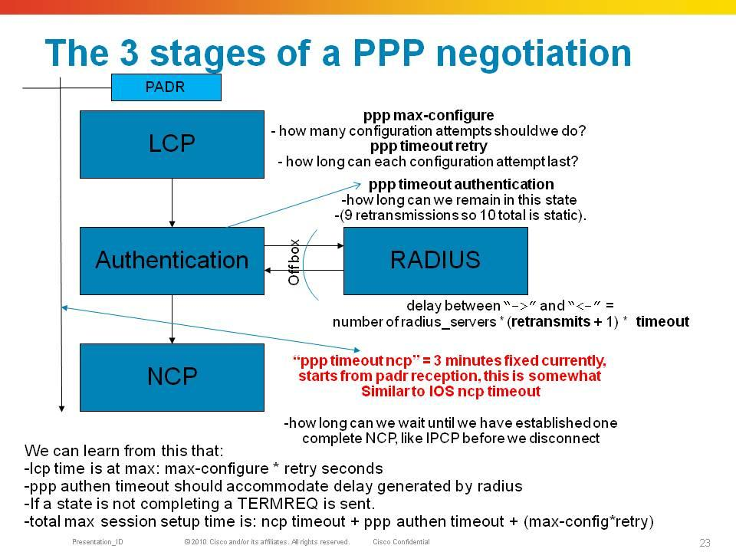
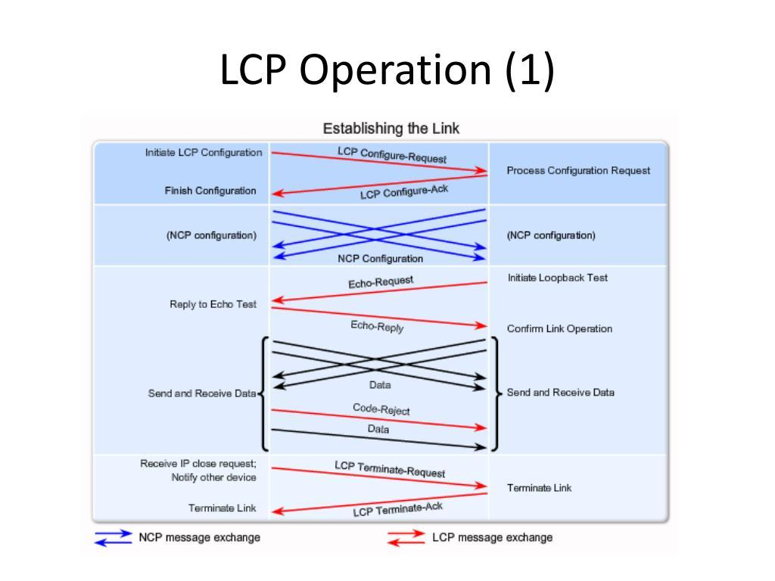
Stage 1: Link establishment
The routers use LCP (Link Control Protocol) to establish and negotiate link parameters.
Stage 2: Authentication (optional)
PPP can authenticate the remote device using PAP or CHAP.
Authentication is optional unless configured or required by the link's policy.
Stage 3: Network-layer configuration
PPP uses NCPs, such as IPCP for IPv4, to configure network-layer protocol parameters.
Stage 4: Data transfer
Once the link is established and the network-layer protocol is configured, the routers can exchange IP packets.
Stage 5: Link termination
LCP can terminate the PPP connection when the link is no longer needed.
LCP manages the PPP link, authentication can verify the remote peer, and NCP configures the network-layer protocol.

9. Demonstrate PPP vs HDLC
On R1, execute:
configure terminal
interface serial 0/0/0
encapsulation hdlc
end
R2 is still configured for PPP.
Now run:
show interfaces serial 0/0/0
Then test:
ping 10.0.0.2
The IP connectivity should fail because the two ends use incompatible encapsulation.
Restore PPP on R1:
configure terminal
interface serial 0/0/0
encapsulation ppp
end
Wait for the link to recover and test the ping again.
This experiment illustrates why both ends must agree on the data-link encapsulation.
Note: Cisco HDLC and PPP are different encapsulation methods. The mismatch demonstrates a Layer 2 compatibility problem rather than an IP-addressing problem.

10. Questions
- What is PPP?
- At which OSI layer does PPP operate?
- What is the purpose of LCP?
- What is the purpose of NCP?
- What are PAP and CHAP?
- Why must both ends of a PPP connection use compatible encapsulation?
- What is the difference between PPP and HDLC?
- Why is a clock rate required on the DCE end of a serial link?
- What is the purpose of the encapsulation ppp command?
- Can PPP carry IPv4 packets?

If your lab experiment does not work then try following add static route on each of the routes below are commands for Router 2 you will need to run the same commands on Router 1 also
R2#show controllers serial 0/0/0
Interface Serial0/0/0
Hardware is PowerQUICC MPC860
DTE V.35 TX and RX clocks detected
idb at 0x81081AC4, driver data structure at 0x81084AC0
SCC Registers:
General [GSMR]=0x2:0x00000000, Protocol-specific [PSMR]=0x8
Events [SCCE]=0x0000, Mask [SCCM]=0x0000, Status [SCCS]=0x00
Transmit on Demand [TODR]=0x0, Data Sync [DSR]=0x7E7E
Interrupt Registers:
Config [CICR]=0x00367F80, Pending [CIPR]=0x0000C000
Mask [CIMR]=0x00200000, In-srv [CISR]=0x00000000
Command register [CR]=0x580
Port A [PADIR]=0x1030, [PAPAR]=0xFFFF
[PAODR]=0x0010, [PADAT]=0xCBFF
Port B [PBDIR]=0x09C0F, [PBPAR]=0x0800E
[PBODR]=0x00000, [PBDAT]=0x3FFFD
Port C [PCDIR]=0x00C, [PCPAR]=0x200
[PCSO]=0xC20, [PCDAT]=0xDF2, [PCINT]=0x00F
Receive Ring
rmd(68012830): status 9000 length 60C address 3B6DAC4
rmd(68012838): status B000 length 60C address 3B6D444
Transmit Ring

Do not forget to define route for 192.168.1.1 on R2
enable
configure terminal
ip route 192.168.1.0 255.255.255.0 10.0.0.1
end
also on router R1 we need to define router to 192.168.2.1
enable
configure terminal
ip route 192.168.1.0 255.255.255.0 10.0.0.1
end

